If you want to become great at Data Engineering, then learn these 15 concepts:
1 How Data Warehouses Work
→ https://lnkd.in/eFHffKM3
2 How ETL vs ELT Works
→ https://lnkd.in/eByu9T9i
3 Data Modeling 101
→ https://lnkd.in/enDBSJCp
4 Dimensional Modeling Explained
→ https://lnkd.in/ehZrxa34
5 How dbt Works
→ https://lnkd.in/eiYiqcfd
6 SQL Optimization Core Concepts
→ https://lnkd.in/ebj7Xk5z
7 How Partitioning & Clustering Work
→ https://lnkd.in/eAtdGZPe
8 Batch vs Streaming Pipelines
→ https://lnkd.in/eFd8suPS
9 How Apache Airflow Works
→ https://lnkd.in/ersqxFyG
10 Data Quality Checks 101
→ https://lnkd.in/e6dxAm4i
11 CDC: Change Data Capture Explained
→ https://lnkd.in/eGd5b5yP
12 How Data Lakes Work
→ https://lnkd.in/eX2Bta5U
13 Lakehouse Architecture 101
→ https://lnkd.in/eDNGDFYn
14 How Apache Iceberg Works
→ https://lnkd.in/em2KUhNe
15 Data Governance & Lineage Basics
→ https://lnkd.in/ehqDPjB5
Activate to view larger image,
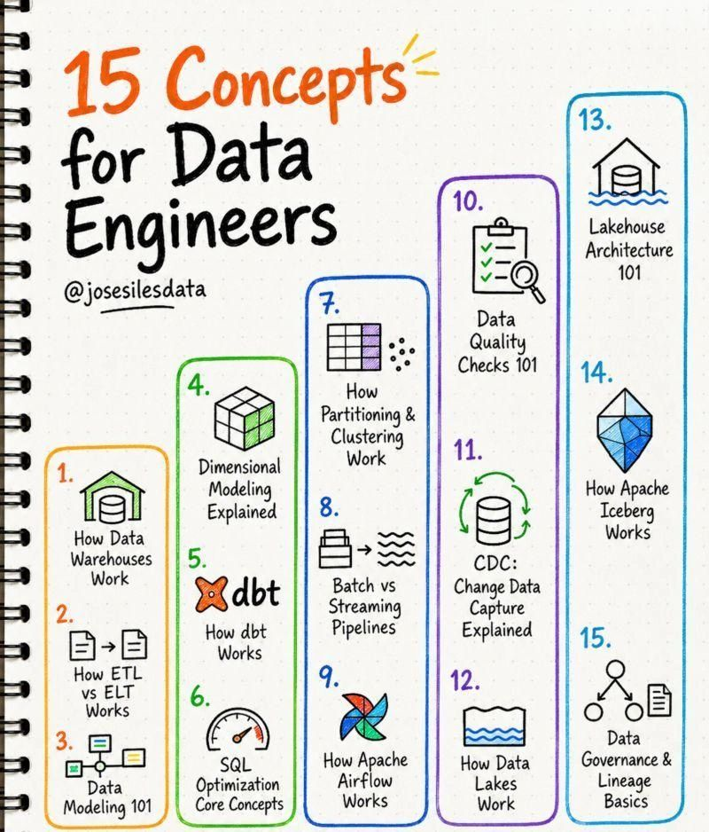

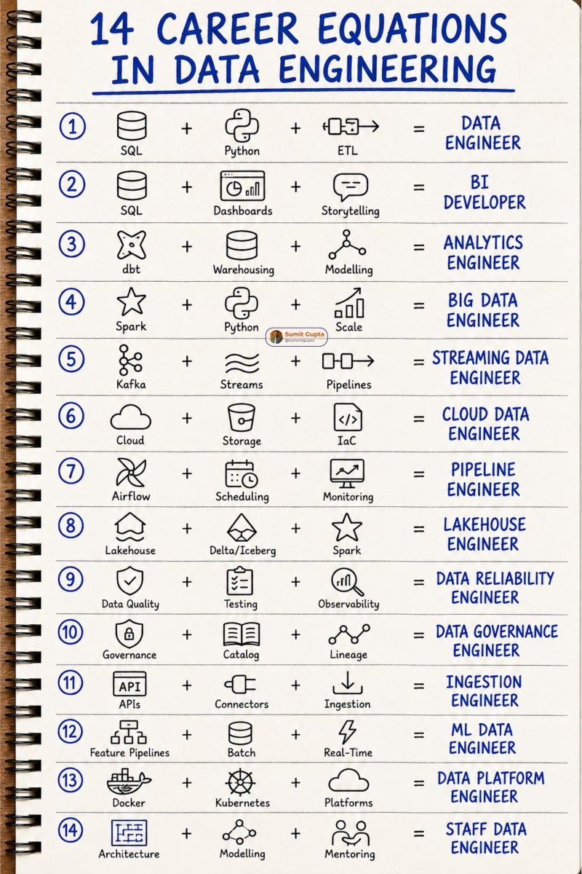

🚀 Data Engineering isn't just about writing Spark jobs. It's about building reliable systems that transform raw data into business value.
I came across this Data Engineering Cheatsheet, and it's a great visual summary of the end-to-end data engineering ecosystem.
It covers the complete journey:
✅ Data Sources
✅ Batch & Real-Time Ingestion
✅ ETL vs ELT
✅ Data Lakes & Data Warehouses
✅ Lakehouse Architecture (Bronze → Silver → Gold)
✅ Data Modeling
✅ SQL Transformations
✅ Workflow Orchestration
✅ Data Quality & Observability
✅ Data Lineage & Governance
✅ Distributed Processing
✅ CI/CD for Data Pipelines
✅ Analytics & Business Insights
As data engineers, we often focus on individual technologies like Spark, Kafka, Airflow, AWS, Databricks, or Snowflake. But what truly differentiates senior engineers is understanding how all these components work together to build scalable, reliable, and production-ready data platforms.
A strong data engineer doesn't just move data—they ensure it's:
✔ Reliable
✔ Scalable
✔ High Quality
✔ Observable
✔ Governed
✔ Ready for analytics and AI
I'm continuously learning and strengthening my understanding of the complete data engineering architecture, and resources like this are great for revisiting the fundamentals.
Which area do you think is the most underrated in Data Engineering?
Mine would be Data Observability & Data Lineage—they become critical as pipelines scale.
Credit: Abhisek Sahu for the original cheatsheet.
hashtag#DataEngineering hashtag#BigData hashtag#ApacheSpark hashtag#Kafka hashtag#AWS hashtag#Databricks hashtag#ETL hashtag#ELT hashtag#DataLake hashtag#Lakehouse hashtag#DataWarehouse hashtag#Airflow hashtag#SQL hashtag#Python hashtag#Cloud hashtag#Analytics hashtag#DataPlatform hashtag#DataQuality hashtag#DataGovernance hashtag#Learning hashtag#TechCommunity
Activate to view larger image,


